**Cherrybrook Public School P&C Association**

**CHERRYBROOK PUBLIC SCHOOL BAND**

Band Parents’ Handbook

2025

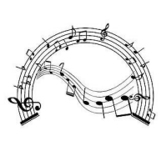

**THE CHERRYBROOK PUBLIC SCHOOL BAND PROGRAM**

Welcome to the Cherrybrook Public School Band Program. All students who will be in Years 3-6 in 2025 are invited to join this successful extra-curricular program at Cherrybrook Public School.

Our Band Program provides outstanding opportunities for children to learn instruments, develop as musicians and enjoy the social benefits of interacting with children from other years. The Band Program gives children the opportunity to learn and play an instrument within the discipline of a group, under the direction of our Band Conductors. Children join the Training Band for their first year and then graduate to the Intermediate Band, followed by the Concert Band (students usually are asked to sit an audition prior to joining the Concert Band). Students in the Concert Band may be invited to join the Big Band. Students are expected to participate in private lessons, performances and weekly rehearsals throughout the year.



**BAND ADMINISTRATION**

The Band Committee works in partnership with the Conductors, P&C and the School Principal and Deputies to ensure the successful administration of the band program.

The Band Committee communicates with band members in the following ways:

● Email

● Band notes distributed to each band member, via School Bytes or BandForte

● School Newsletter & Website

The contact details for the Band Committee are issued early in the New Year. **All** email communication goes through cherrybrookpublicschoolband@gmail.com Please save this email to your contacts to ensure emails do not go to your Junk/Spam folders.

**COMMITMENT TO BAND**

A band can only survive and improve if it has dedicated members who regularly practise together. Students will improve individually through private tutoring and practice at home. Once a commitment has been made to the band, **it is important that each student endeavours to remain in the band for the full year.** Your commitment to the band is like being part of a sporting team and we would ask that if you no longer wish to be a part of the band that **you do not resign until the end of a semester**.

Band members leaving mid semester will be charged for the full semester.

The following semester’s fees will also be charged unless written notification has been received by the Band Committee and any school instruments returned to the Instrument Coordinator. Learning a musical instrument requires commitment by both the student and the parents/caregivers. You should ensure that your child is attending private instrumental lessons once a week.

**Student’s Commitment**

**Lessons**

The student needs to undertake tuition from a recognised teacher of their designated instrument. Without lessons, the children will be unable to sufficiently master their instrument. This will undermine their own enjoyment of the band experience and impede the progress of others.

Tuition is a private matter between parents and tutors. You may make arrangements with one of the tutors suggested by the Band Program (a list is provided on request) or with a tutor of your choice. Tutors may encourage students to undergo the AMEB or Trinity music examinations; these are beneficial as they ensure students will continue to improve. Students are expected to have face-to-face lessons with a tutor. Tutors may offer online lessons and will most likely move to online lessons if COVID restrictions are introduced.

**Practice**

The student needs to make a commitment to practise each week at home. Ideally the student should be practising between four to five times each week for a minimum of 20 to 30 minutes.

**Music**

The student needs to care for all sheet music and band folders issued to them. Copies of the required music will be stamped and numbered for each child who must place it immediately in the band folder supplied. All music and folders are to be used for band and practice purposes only. The band folder remains the property of the school. All folders and music MUST be returned at the end of each year. Families will be charged for any damage to this folder or loss of music. Please note that a charge of $25 will apply for lost folders or a $8 charge per damaged sheet of music.

**Rehearsals**

The student needs to be committed and punctual at all rehearsals and performances. Students need to bring their instrument, music, pencil, and eraser to all rehearsals. It is a requirement of the band program for all students to assist with setting up and packing away.

**Parent’s Commitment**

For your child to get the most from the Band Program there are a few things you can do to help. Recognise that **you** are as much a part of the Band Program as your child and:

● ensure that your child is attending private instrumental lessons once a week

● encourage your child to practise on a regular basis

● support them through the challenging times

● transport your child to and from band rehearsals and performances on time; late arrivals are

disruptive to all students.

● assist with organising their online setup (if required)

● support your child's band when they play in public

● ensure your child takes good care of their instrument

● pay all fees promptly on receipt of the account without the need for follow up by our volunteer band committee. If prompt payment causes an issue for you, please speak to the Band Coordinator in advance, in the strictest of confidence.

**Parents are required to contribute to the band:**

**Parent Compulsory Obligations**

Parents are requested to give 6 (six) hours of assistance for the first child and 4 (four) hours for the second child towards the band program every year. This includes assisting with the setup and packing up during the rehearsals, volunteering at the Band Camp, Workshops and various performances.

It is **vitally important** that each family attends and assists with **rehearsals** for each child in Training Band, Intermediate Band and Concert Band; (at present, Big Band do not require a parent volunteer at rehearsals). You will have the opportunity to nominate suitable times and dates at the start of each term via the sign up form link which will be emailed directly to you by your Band Supervisor.

If personal circumstance does not allow you to supervise at rehearsals, you may nominate another adult to attend on your behalf. This must be discussed with the Band Coordinator and will be in confidence.

A $90 Levy will be charged and included in the Semester 1 invoices and will be refunded at the end of the year on completion of the required volunteer hours. Please note that the band committee would much prefer parental assistance.

**Declaration for Volunteers**

As part of the Parent Obligations, **ALL** parents* **MUST** have completed a Working with Children Check - Declaration for Volunteers and sign the Code of Conduct. The Code of Conduct will be emailed to you via School Bytes during Term 1.

* If you are a parent that has **NOT** volunteered at the school in the past, you are required to do the following;

1. Complete a - Working with Children Check - Declaration for Volunteers and Non-Child Related Contractors

[https://education.nsw.gov.au/content/dam/main-education/policy-library/public/implementation-documents/pd-2005-0264-07.pdf](https://aus01.safelinks.protection.outlook.com/?url=https%3A%2F%2Feducation.nsw.gov.au%2Fcontent%2Fdam%2Fmain-education%2Fpolicy-library%2Fpublic%2Fimplementation-documents%2Fpd-2005-0264-07.pdf&data=05%7C02%7Crebecca.jager1%40det.nsw.edu.au%7C703bdfe8d5784baaa4d408dbfc2746fc%7C05a0e69a418a47c19c259387261bf991%7C0%7C0%7C638381017840537813%7CUnknown%7CTWFpbGZsb3d8eyJWIjoiMC4wLjAwMDAiLCJQIjoiV2luMzIiLCJBTiI6Ik1haWwiLCJXVCI6Mn0%3D%7C3000%7C%7C%7C&sdata=Xk0PGwsZh%2BZNRoaqKqP6UMSAxsGx1pyFJmjJJhcqHjM%3D&reserved=0)

2. Submit the Declaration for Volunteers to the School Office along with a government issued photo identification including your address (e.g., Driver’s License)

**You only need to complete this declaration once during your child’s education at Cherrybrook Public School. If you have completed one in the past at Cherrybrook Public School, you do not have to do it again.**

**INSTRUMENT INFORMATION**

**Instrument Care**

Students and parents are expected to take proper care of their instruments whether they are personal property or that of the school. Please check with your tutor on how to care for and maintain your specific instrument. If your child's instrument requires a repair, you must contact the Instrument Coordinator and Band Coordinator in the first instance to be assessed. Please DO NOT take the instrument directly for repair without the proper authorisation, otherwise any costs incurred will be at your own expense.

Required accessories include:

● A "pull through" or similar cleaning device (flutes, clarinets, saxophones)

● A reed cap, cork grease and a minimum of three reeds in good order, that are not chipped or split (clarinets, saxophones)

● Valve oil or slide cream, tuning slide grease and a large soft cloth for cleaning and drying (all brass instruments)

● Mallet bag with drumsticks (percussion) purchased through the band program.

**Types of Instruments**

The Cherrybrook Public School Bands are made up of woodwind, brass and percussion instruments. Instruments used in a concert band include Flute, Oboe, Clarinet, Bass Clarinet, Alto Saxophone, Tenor Saxophone, Baritone Saxophone, Trumpet, Trombone, Euphonium, French Horn, Tuba, Bass Guitar, Percussion, and Drums. Most of these instruments are available from the school for hire.

Students nominate three instrument preferences. The Band Committee will review all instrument applications and advise students regarding their successful instrument choice in Term 4.

Band members can purchase their own instrument, borrow one from family/friends, hire one through the Band Committee or hire one from a music shop. Please note, the committee does not hire out Oboes or Drum kits. If your child is interested in learning the Oboe or percussion you must be able to source your own instrument.

**Hire of School Instruments**

By taking possession of a school instrument parents are agreeing to ensure the instrument is looked after and returned in the same condition it was in when hired. If a school-owned instrument has any problems at all, the school band committee MUST be contacted in the first instance for advice.

Families are requested not to seek repairs to a school-owned instrument without the guidance of the CPS Band Instrument Coordinator.

Instruments are hired out with accompanying accessories where appropriate e.g., a cleaning rod for flutes, a neck strap for Alto Saxophones, a stool for Tuba and a body harness for Tenor saxophones. These accessories must be returned when the instrument is returned, or the replacement cost will be deducted from your bond payment.

A **deposit of $100** is required prior to issue of the instrument. This deposit is returned when the instrument and accessories are returned in good condition. The cost of the final service will be deducted from the bond if the student leaves the band or returns the instrument mid-year. Music Folders must also be returned or the cost to replace them will be deducted from the bond.

**Insurance**

In the event of serious damage or loss of a hired instrument, your home contents insurance policy may provide cover for the item which is in your care, custody and control. In the event of loss or damage you will need to approach your insurer and seek to claim. If the claim is denied, a copy of the insurer’s letter of denial must be provided to the band committee and school.

It is the responsibility of the student to return the hired instrument and their music folder to the Band Committee upon leaving the band. If an instrument is returned before the Semester 1 invoices, the $100 deposit is forfeited in order to cover servicing and specialised cleaning.

**School Instruments for Percussionists**

Whilst there are currently no percussion instruments available to hire, please be advised that all Percussionists must purchase their mallet bag through the Band Program. This is a specific set that has been highly recommended and is used by local tutors. The cost for 2025 is approximately $275.

**Tutors and Private Lessons**

It is a condition of the Band program that band members have a private face-to-face instrument lesson once a week outside school hours. Please ensure the band music is taken to lessons and practised with your tutor. Once a student has received their instrument allocation and accepted their place into the band, parents must secure a tutor immediately. Instruments are distributed to students before the end of Term 4 in the year before they begin band. Students must start lessons as soon as possible. ***Training Band students must have at least 4 lessons before the first week of Training Band.*** This ensures that students learn to hold, play and clean their instruments correctly and that band rehearsals are used for instrument and music collaboration, **NOT** individual instrument tuition.

A ‘Tutor List’ is provided on request. The Committee gives no endorsements or recommendations. It is the responsibility of each child's parents to ensure the tutor conforms to the Child Protection laws.

Please note that music handed out to your child is **NOT** to be copied. Music is subject to copyright laws and whilst the band may distribute photocopied music, it has been photocopied within these laws.

**REHEARSALS**

The Band Director(s) will hold weekly band rehearsals in the school hall.

**Concert Band: Monday 7.15am - 8.30am AND Tuesday 2.55pm - 4.00pm**

**Intermediate Band: Tuesday 7.15am - 8.30am**

**Training Band: Wednesday 7.15am - 8.30am**

**Big Band: Tuesday 4:05 - 4.55 pm**

Band Rehearsal Days & Times may change due to unforeseeable circumstances. Restrictions put in place by the Department of Education can occur at short notice, preventing face-to-face rehearsals. With this in mind, the band utilises Google Meet to hold rehearsals online during the above times. Students must ensure they know how to access Google Meet at home.

Band members must arrive promptly for morning rehearsals with enough time to set up their instrument and music, ready to play at their rehearsal start time. Attendance at band rehearsals is compulsory. If rehearsals are held online, parents must communicate with the band committee if extenuating circumstances restrict attendance.

It is also appreciated that parents assist with setting up or packing up chairs, instruments and music stands before/after rehearsals even when you are not rostered on.

Band members are expected to behave in a courteous and committed manner at all times during rehearsals. Any band member who misbehaves will be asked to sit out the rehearsal and will be reported to the School Deputy Principal, who will then call the band member's parents.

*Changes will be communicated via email and School Bytes.

**AWARD SCHEME**

The award scheme (which is in line with CPS whole school award system) is designed to encourage students, as well as recognise their musical achievement and efforts during rehearsals and throughout the year. The award scheme involves students receiving Mini Merits. Please see the flow chart for more information.

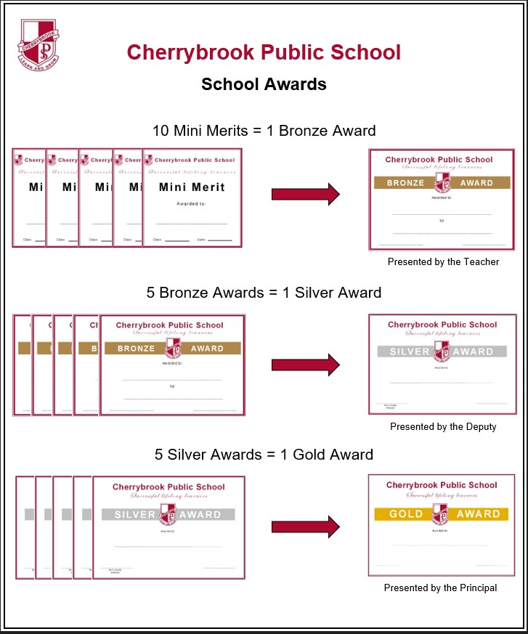

**PERFORMANCES**

Band performances are scheduled throughout the year and are a **compulsory** requirement of the band program. Extenuating circumstances for missing a performance must be explained, in writing, to the Band Committee and Band Conductor in advance of any performance.

Please note some of these performances, festivals, workshops and competitions, are held on the weekend. A calendar with performance dates is sent out at the beginning of the year and updated as necessary.

We are advising below the types of competitions and events the bands are likely to perform in each year.

● Sydney Eisteddfod ***All Bands***

● Public Education Day during the school day *Concert & Big Band*

● Cherrybrook Public School Band Information Sessions ***Intermediate / Concert or Big Band***

● School Assemblies ***All Bands***

● *ASBOF*on a Sunday in August TBC ***All Bands***

● Cherrybrook Soiree on a weeknight evening in October or November ***All Bands***

● Family Concert on a Sunday afternoon in November ***All Bands***

● Cherrybrook Presentation Day during the school day ***Concert Band***

● Inala Fair **TBC *Big* *Band***

**BAND WEEKEND**

The Band Program runs an intensive Band Weekend for all band children. The Band Weekends are held as a two-day event onsite at school over a weekend in April or May. The onsite Band Weekend has always been well received by the student community and allowed focused instrument rehearsals in tutorials, full band rehearsals, and a bit of fun with activities such as laser tag and an obstacle course. Band Weekend is an important learning part of the Band program calendar and it is expected that all children attend.

**BAND POLO SHIRTS** are purchased via Flexischools from the uniform shop. The band committee will advise when these need to be purchased. ***This is a special order and not a regular stock item, therefore if you require a shirt it needs to be ordered at the given time and deadline.*** Polo T-Shirts purchased in 2023 or 2024 may continue to be worn if in good condition. These shirts are worn at Band Weekend, Workshops and less formal performances by the Bands.

* (Please Note: This is not a regular stock item in the Uniform shop and the Band Committee **does not** administer the sale of the Polo T-Shirt. All enquiries must be made to cpsuniform@gmail.com.)

**WEEKEND WORKSHOP**

**Compulsory** weekend workshop(s) will be held at the school in preparation for the Band Festivals and any other major performances. These traditionally run on a Saturday or Sunday afternoon(s), often having one in Term 1 or 2 and a second in Term 3.

**BAND FEES**

**Application Fees - for Hirers**

|  |  |
| --- | --- |
| Enrolment Fee (Paid on accepting a place) | $50 |
| School Instrument Deposit (Refunded, minus Service Fees on returning the instrument undamaged) | $100 |
| Hire Instrument Care Kit (Issued with all new hires) | $30 |
| Accent on Achievement Music Book | $30 |

**Application Fees - for Non-Hirers**

|  |  |
| --- | --- |
| Enrolment Fee | $50 |
| Accent on Achievement Music Book | $30 |
| Percussionists Only - Mallet Bag | $275 |

An estimated schedule of fees is included below, however please note these are “subject to change.” Please read through carefully.

**Training Band**

1. **Either:**
   1. **Band Fee - Non Hirer:** $150 per Semester

**Or**

* 1. **Band Fee - Inc Instrument Hire:** $285 per Semester

1. **Duty Levy:** $90 per year. Invoiced on the Semester 1 Invoice and refunded on completion of Parent Volunteer Obligation Duty Hours
2. **Band Polo T-Shirt:** $40 via the School Uniform Shop on Flexischools **\* This is a special order and not available in stock all year round.**

**Intermediate Band**

**1. Re-enrolment Fee:** $40 (Issued within the Semester 1 Invoice)

**2. Either: a. Band Fee - Non-Hirer:** $150 per Semester

**Or**

**b. Band Fee - Inc Instrument Hire:** $285 per Semester

**3. Duty Levy:** $90 per year. Invoiced in Semester 1 and refunded on completion of Parent Volunteer Obligation Duty Hours at the end of the year.

**4. Band Polo T-Shirt:** $40 via the School Uniform Shop on Flexischools \***This is a special order and not available in stock all year round.**

**Concert Band**

**1. Re-enrolment Fee:** $40 (Issued within the Semester 1 Invoice)

**2. Either: a. Band Fee - Non Hirer:** $180 per Semester*

**OR**

**b. Band Fee - Inc Instrument Hire:** $315 per Semester*

**1. Duty Levy:** $90 per year. Invoiced on the Semester 1 Invoice and refunded on completion of Parent Volunteer Obligation Duty Hours at the end of the year.

**2. Band Polo T-Shirt:** $40 via the School Uniform Shop on Flexischools * **This is a special order and not available in stock all year round.**

**Big Band**

1. **Fee:** $95 Per Semester
2. If you plan to hire the 2nd instrument offered to your child from the school, a $135.00 is payable making payment directly to the band (of which $100.00 is a non-refundable security deposit and $30 payment for purchase of a Care Kit)
3. There is no requirement to have lessons if you are taking up a 2nd instrument in Big BAND

**Band Weekend Fees**

These fees are listed to give families a rough idea of what fees may apply to a band weekend. In 2022 and 2023 an onsite day only Band Weekend was held at school and cost $130 per child. In 2025 Band Weekend Cost cost per child is $140.00. **Families with two or more children participating in band are eligible for a sibling discount on the band fee only, full hire fee will still apply.**

Band Fees are usually invoiced in both February and July and payments are due by the end of the month. Invoices are paid via Bank Direct Deposit only. Semester 1 Band Invoice covers school terms 1 and 2 and Semester 2 Band invoice covers school terms 3 and 4.

Fees are used to pay the Band Conductor(s), purchase music, tutor costs, replace and provide new instruments, and miscellaneous costs such as competition entry fees.

Training Band members will be issued with an “Accent on Achievement” instruction book. The tutorial book “Accent on Achievement” is to be used by the Training Band members in their weekly private lesson and will also be used in the weekly band rehearsal.

**LOST MUSIC AND FOLDER FEES**

One piece of damaged/lost sheet music $8.00

Whole Folder damaged/lost $25.00

Each member of the band will be issued a band folder, which remains the property of the school. The folder and music must be returned at the end of each year. Any damage to this folder or loss of music will result in a charge to the parents.

**DUTY LEVY - Please Read Carefully**

A duty levy is set at **$90.00 per year** which is invoiced in Semester 1 and will be refunded at the end of the year for parents who have fulfilled their Parent Volunteer Obligations (i.e. at Band weekend, 2 workshops, fundraisers, competitions etc) per child during the year. 6 (six) hours of parent volunteer time for the first child and 4 (four) hours of parent volunteer time for the second child per year is required for the efficient running of the rehearsals, events, etc.

**COMMUNICATION / CORRESPONDENCE**

Should you have any queries please refer to the school website. https://cherrybrok-p.schools.nsw.gov.au/parents---citizens-association/band-program.html

Should you not be able to resolve your query please email the Band Secretary. cherrybrookpublicschoolband@gmail.com

**Please allow 72 hours for a response. All Committee members are volunteers and along with managing their committee obligations, they have full time jobs and family commitments which take priority.**